Control Systems Lab

Lab 4 In-Class: Feedback Control Basics

Objectives
- Review components and structure of a feedback control system
- Investigate effects of proportional, derivative, and integral control action
- Understand separate components of the DC motor system and how they interconnect to achieve feedback control

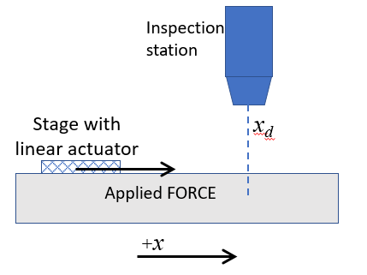
Part 1: Feedback control architecture

Source: https://averroes.ai/blog/aoi-semiconductor
  - Consider a positioning stage in a semiconductor inspection tool that moves a component to a target location, $x_{d}$. A linear actuator applies a force to the stage carrying the microelectronic chip. A sensor package provides position and speed of the stage, as well as time. Draw by hand a block diagram representing feedback control for the position of the stage, $x$, assuming proportional control. Label all blocks and wires in the diagram. Upload an image of your block diagram to Gradescope.

  - What is the specific control law for 1.1 if a proportional controller $K_{p}$ is used? Write this equation in terms of the quantities labelled in your diagram.

Part 2: Proportional, integral, and derivative control
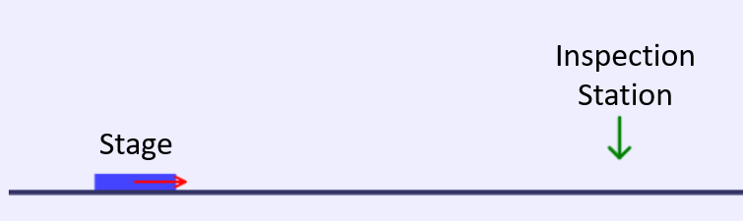
For this part of the lab, you will use an online game that simulates the stage motion in the inspection system. You will investigate the effects of proportional, derivative, and integral control. Use the following address to access the game:
http://labineering.com/CC/
Open Tutorial #1 using the Level menu:
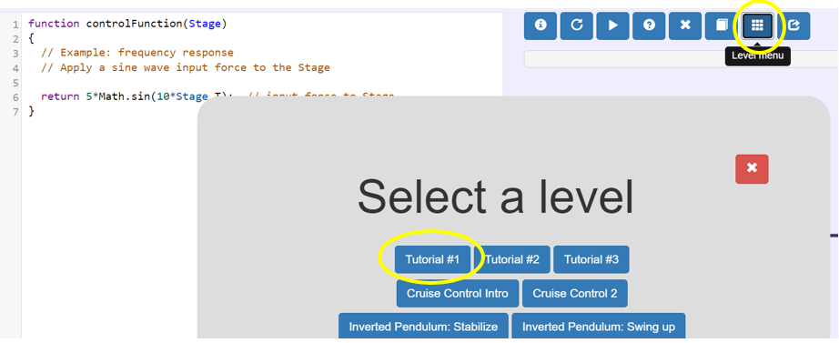

First try some OPEN LOOP scenarios:
  - Frequency response (recall Lab 3): Press the “Play” button and observe the Stage responding to a sinusoidal applied force. Notice that the sensor outputs appear on the right. Which of the available sensor outputs does the expression in the ‘return’ line use? What happens to the position of the Stage with this input force? Enter your answers in Gradescope.

  - Step response (recall Lab 2): Change the applied force to a unit step input as shown below and press the “restart with code changes” button. What signal reaches a constant steady state value in this case? Enter your answer in Gradescope.
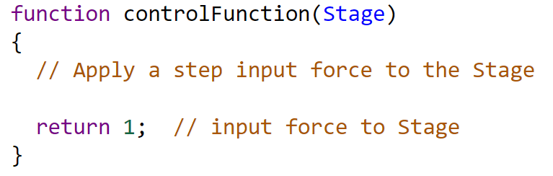
Now you will set up the code for CLOSED-LOOP control to move the stage to the inspection station:
2.3 Change the code to apply the control law you identified in part 1.2. Press the “Restart with code changes” button. Vary the gain of the proportional control and describe what happens with lower and higher gains. Enter your brief observations in Gradescope – specifically about the performance of a control system (speed, stability, steady state error).
2.4 Find the value of the proportional gain (to two decimal places) that has the fastest response with no overshoot (force arrow on block should never point left). In Gradescope, provide a screenshot that shows both the code with that gain, and the Stage at the target position at the final time.
Next, open Tutorial #3. Push the “Sample solution” button.
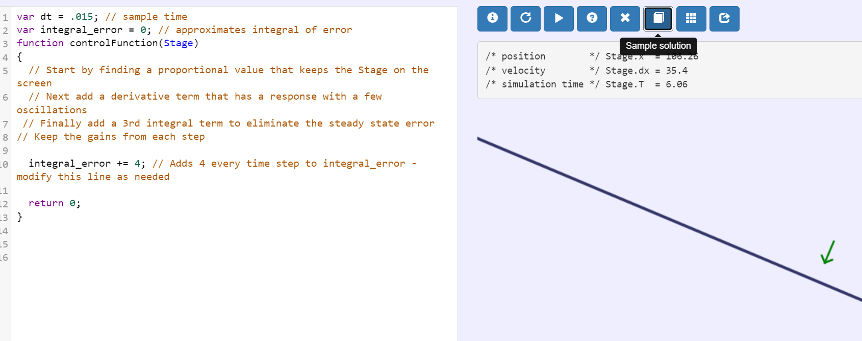

This simulation will investigate a system with an inclined track. Your objective is to reach the inspection station accurately at steady state; some overshoot is acceptable. Controller gains shouldn’t be more than 10.
2.5 Set up the input to include a proportional term. Vary the proportional gain and describe what you observe in terms of transient behavior (e.g. oscillations, settling time), stability, and steady state error. Find a proportional gain for the best response (e.g. reduced overshoot).
2.6 Starting with the proportional gain from question 2.5, include a derivative term in the control law and describe what you observe. What does the derivative action appear to do in general? How does the behavior change when you vary the derivative gain? Modify the derivative gain to obtain the best response and use the proportional and derivative gains as a starting point for the next section.
Hint: Write down your new control law on paper first -- your code should represent this equation
2.7 The code for this part will include a new variable to approximate the integral of error, “integral_error” (Push the “Sample solution” button to get this code). Use this variable to include an integral term using the numerical implementation you wrote down in Prelab 4. What does the integral action appear to do in general? How does the behavior change when you vary the gain?
2.8 Upload to Gradescope a screenshot showing the code with your control law.

Part 3: Components of DC motor feedback control system
In Labs 2 & 3 we used Simulink to define the voltage to send to the motor, and to read the motor position or velocity. In this activity, we will investigate those blocks in more detail and introduce a potentiometer as a reference input. These blocks will be used to build a closed loop control system to control the motor in subsequent labs.
Connect a DC motor to your USB port and open the Simulink diagram, “M2V5_Motor_Reference_Actuator_Sensor.slx”
3.1 Potentiometer Reference Input: Make sure the motor voltage is set to 0 so the motor is not spinning. Observe the scope for the potentiometer as you move the potentiometer dial back and forth.
  - Move the potentiometer approximately $π$ radians– how much does the scope value change?
  - What is the conversion factor (leave as a fraction – do not multiply out) to go from the potentiometer units to radians?
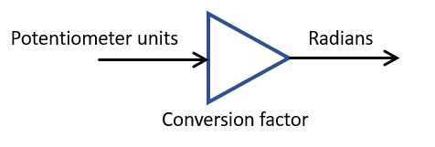
3.2 Sensor/Output Measurement: Make sure the motor voltage is set to 0 so the motor is not spinning. Observe the scope for the Encoder Output Measurement as you move the motor disk back and forth by hand.
- Move the motor wheel approximately $2π$radians – how much does the scope value change?
- What is the conversion factor (leave as a fraction – do not multiply out) to go from the encoder units to radians?
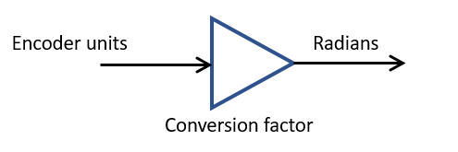
  - Command/Actuator Signal: Observe the motion of the motor wheel as you change the Motor Voltage from 0 to 5. Is a positive voltage clockwise or counterclockwise (looking at front of the disk)?

3.4 Control System Block Diagram: Using ONLY the blocks in the Simulink diagram, construct the block diagram for the feedback so the motor will go to the position specified by the potentiometer. (Hint: this is similar to the sketch in Prelab 4, question 2. Also, similar to In Class Lab 1 exercises, what is the control law (equation) you want to make with the block diagram?) Upload a screenshot of your block diagram.
- Do not use any types of blocks not already present
- OK to copy or delete blocks as needed
- Make sure units are correct
- You do not need to run this, just upload a screenshot – you will run it next lab

